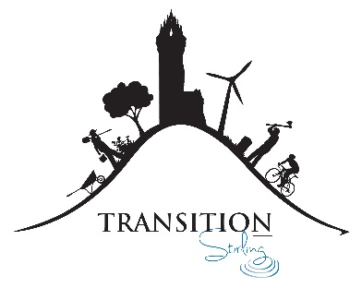

Hannah - Can you tell us a bit about the Transition Ripples event you organised?
I organised a workshop where we fused colourful old plastic bags together to make new useful objects like purses, wallets, keyrings, storage cases... and some batwings. The opportunities are endless! We used an iron and some greaseproof paper to seal the plastic layers together into something new and there was a sewing machine on hand to sew plastic pieces together.
How did you decide your topic? Was this something you knew a lot about?
I had seen some other people carrying around cool looking handmade plastic items before, and decided to look into how to make them on youtube. It seemed pretty straightforward so I began to experiment, and then got pretty into creating new useful things out of waste plastic! It was so easy, and so satisfying to create new things out of ’waste’ that I wanted to share the idea with others. I’m by no means an expert, but you don’t need to be.
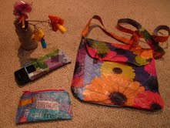 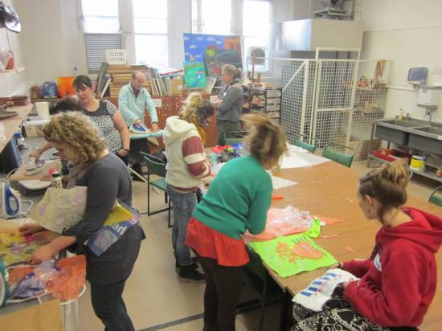
How did you find the process of planning it?
Quite straightforward - there was not too much involved as other people from Transition Stirling helped to find and book the venue, and it only took a few minutes to put together the information for the website and facebook page.
How did it go on the day?
It went really well on the day - I was pleasantly surprised to find everyone else just as excited as I was about reusing plastic into something fantastic! Everyone came with their own ideas about things they would like to make, and there were some really impressive creative ideas like the batwings, and a personalised folding wallet with separate pouches.
Were there any big challenges?
No not really. Borrowing enough irons and ironing boards so that lots of people could iron plastic at the same time? Trying to avoid melting plastic onto the irons?! I did lose a beautiful flowery handbag I had made as a demo in amongst the overflowing piles of plastic bags which later got taken to be recycled at the supermarket. Ah well!
Do you think it’s something you would do again?
Yes, definitely - it was lots of fun, and great meeting so many other people excited a about creating new things from waste!
Do you have any advice you’d give to anyone thinking about running their own Ripples event?
Pick something you are passionate about, but don’t feel you have to be an expert in it. Having a creative assistant along to help on the day was really good - thanks to my Mum for that, she was the sewing machine expert!

